Name Of The Student | Garima Modiyani
Internship Project Topic | TCS iON RIO-210: Build a Classification Model for Drug Trials Dataset
Name of the Organization | TCS iON
Name of the Industry Mentor | jignasha royala
Name of the Institute | Amity University

Date | Day | Hours Spent
13-11-2025 | Day-35 | 4 hours 40 minutes
Activities done during the day:

Fitting the data to model using python.

Data fitting:

Python is a power tool for fitting data to any functional form. You are no longer limited to the simple linear or polynominal functions you could fit in a spreadsheet program. You can also calculate the standard error for any parameter in a functional fit.

The basic steps to fitting data are:

- Import the curve_fit function from scipy.
- Create a list or numpy array of your independent variable (your x values). You might read this data in from another source, like a CSV file.
- Create a list of numpy array of your depedent variables (your y values). You might read this data in from another source, like a CSV file.
- Create a function for the equation you want to fit. The function should accept as inputs the independent variable(s) and all the parameters to be fit.
- Use the function curve_fit to fit your data.
- Extract the fit parameters from the output of curve_fit.
- Use your function to calculate y values using your fit model to see how well your model fits the data.
- Graph your original data and the fit equation.

Fitting x, y Data

First, import the relevant python modules that will be used.
import numpy as np
import matplotlib.pyplot as plt
from scipy.optimize import curve_fit

Now we will consider a set of x,y-data. This data has one independent variable (our x values) and one dependent variable (our y values). We will recast the data as numpy arrays, so we can use numpy features when we are evaluating our data. It is often very helpful to look at a plot of the data when deciding what functional form to fit.

X_data = [ -10.0, -9.0, -8.0, -7.0, -6.0, -5.0, -4.0, -3.0, -2.0, -1.0, 0.0, 1.0, 2.0, 3.0, 4.0, 5.0, 6.0, 7.0, 8.0, 9.0, 10.0]
Y_data = [1.2, 4.2, 6.7, 8.3, 10.6, 11.7, 13.5, 14.5, 15.7, 16.1, 16.6, 16.0, 15.4, 14.4, 14.2, 12.7, 10.3, 8.6, 6.1, 3.9, 2.1]

#Recast x_data and y_data into numpy arrays so we can use their handy features
X_data = np.asarray(x_data)
Y_data = np.asarray(y_data)
plt.plot(x_data, y_data, 'o')

This data could probably be fit to many functional forms. We will try two different functional forms. (Looking at data and knowing what function it might fit is non-trivial and beyond the scope of this lesson. For purposes of this lesson, we will simply fit the data to given functional forms.)

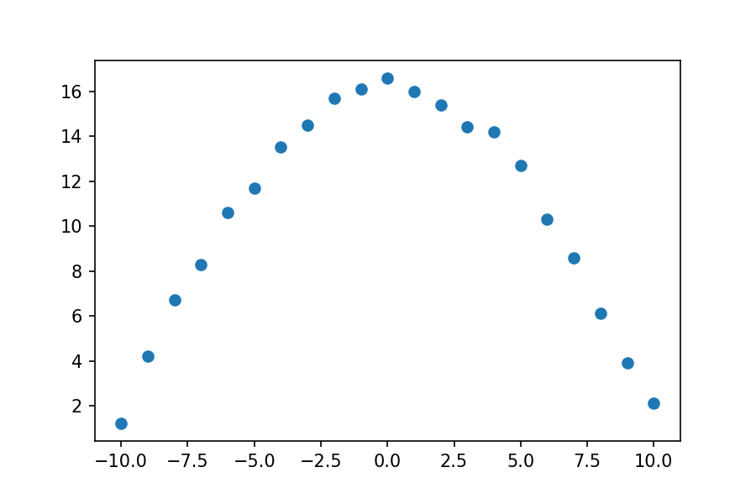

Reference:

https://milliams.com/courses/applied_data_analysis/Fitting.html/

